To start this off I want to apologize over not having colour scheme examples. I am house sitting currently and I left my power cord for my computer at home so I am using a friends Mac

Colours that relate to world cup.

* Russian Flag colors.
* Name: White
* Hex: #FFFFFF
* RGB: (255, 255, 255)
* CMYK: 0, 0, 0, 0
* Name: Philippine Blue
* Hex: #0039A6
* RGB: (0, 57, 166)
* CMYK: 1, 0.656, 0, 0.349
* Name: Maximum Red
* Hex: #D52B1E
* RGB: (213, 43, 30)
* CMYK: 0, 0.798, 0.859, 0.164

Fifa Colors

* Name: Rosso Corsa
* Hex: #D30208
* RGB: (211, 2, 8)
* CMYK: 0, 0.990, 0.962, 0.172
* Name: Gold (Crayola)
* Hex: #E5C685
* RGB: (229, 198, 133)
* CMYK: 0, 0.135, 0.419, 0.101
* Name: Antique White
* Hex: #F5EED5
* RGB: (245, 238, 213)
* CMYK: 0, 0.028, 0.130, 0.039
* Name: Chinese Black
* Hex: #171714
* RGB: (23, 23, 20)
* CMYK: 0, 0, 0.130, 0.909
* Name: Midnight Blue
* Hex: #015386
* RGB: (1, 83, 134)
* CMYK: 0.992, 0.380, 0, 0.474
* Name: Honolulu Blue
* Hex: #0074B1
* RGB: (0, 116, 177)
* CMYK: 1, 0.344, 0, 0.305

Australian colors

* Name: Philippine Green
* Hex: #00843D
* RGB: (0, 132, 61)
* CMYK: 1, 0, 0.537, 0.482
* Name: Tangerine Yellow
* Hex: #FFCD00
* RGB: (255, 205, 0)
* CMYK: 0, 0.196, 1, 0

RMIT Colours

Dark Green

#006500

Gold

#FFD700

Argent

848482

Red

Black

Log in bar

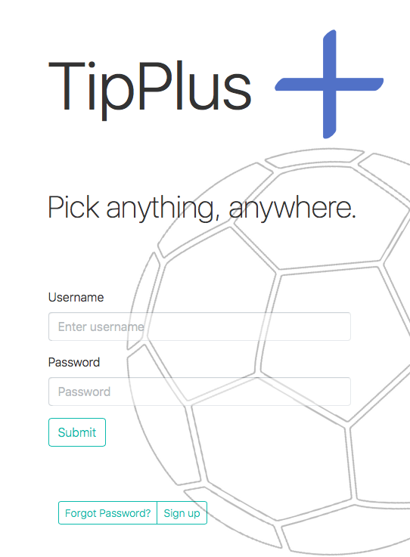

Should we use similar design for sign up page?

How much details is a reasonable amount?

Can we have this type camo pattern on certain hexagons or do you believe simplicity is best?

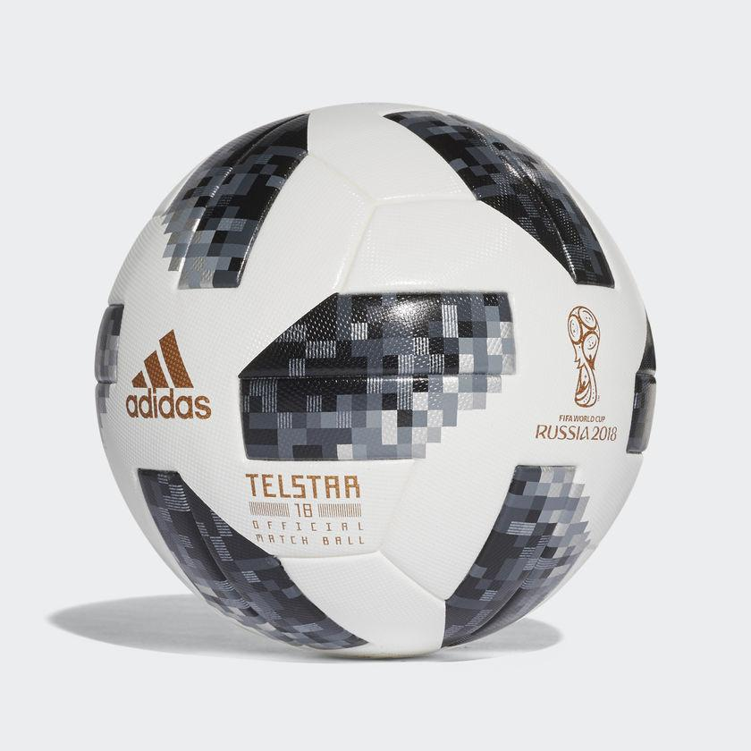

Will log in be just a log in screen or should recent games and upcoming games be below the toolbar like afl app? Example.

Tournament information management.

The world cup ended so should we use the champions league as the main tournament? Should the home page have their last two games and next two.

We need to make a ladder like this

**Pick management.**

Should we compile the team logos for every team in a tournament like the champions league for better viewing?

<http://www.afl.com.au/ladder/ladder-predictor#/round/18>

Should your tips look like this with just a blue tick to press?

Or should the whole name and possible logo go blue?

**Results storage visual end**

We should store the results in the latter rounds in brackets for the later rounds like this <https://www.transfermarkt.co.uk/uefa-champions-league/turnierbaum/pokalwettbewerb/CL/saison_id/2017>

In the group stages

<https://www.fifa.com/worldcup/groups/>

How will we check each team against each other?